**Name:_______________________________ _________ Date:_______________**

Biome WebQuest

**Part I** - Complete the following table using the NASA: Mission Biomes and any other source you need. <http://earthobservatory.nasa.gov/Experiments/Biome/>

°F = (°C * 1.8) + 32.0

| **Biome**  Example Location | **Climate- Temp & Precipitation** | **Typical Vegetation**  **(Plants a/k/a flora)** | **Animals**  **(a/k/a fauna)** | **Location** | **Other: Human Interactions, Uses, Adaptations, Exploitations (abuses)** |
| --- | --- | --- | --- | --- | --- |
| **Coniferous forest (Boreal)** |  |  |  |  |  |
| **Temperate deciduous** |  |  |  |  |  |
| **Desert** |  |  |  |  |  |
| **Grassland-** |  |  |  |  |  |
| **Rainforest-** |  |  |  |  |  |
| **Chaparral**  **(Shrubland)** |  |  |  |  |  |
| **Tundra** |  |  |  |  |  |

**Part II: Great Graph Match** - Look at each graph and determine which biome best fits based on the given data. <http://earthobservatory.nasa.gov/Experiments/Biome/graphmatch_advanced.php>

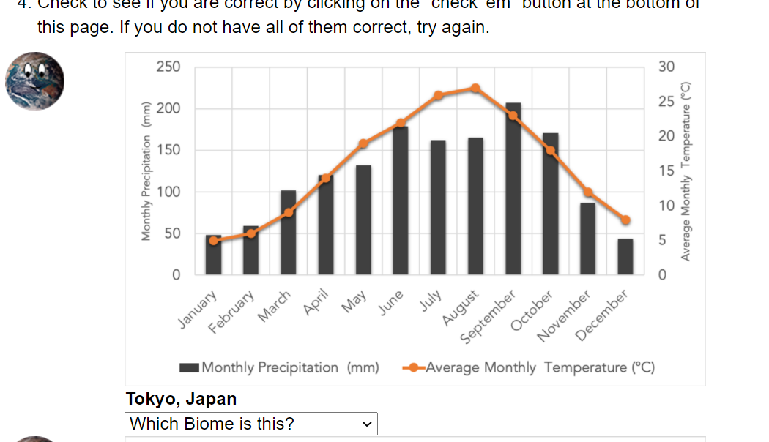

**This is great practice for reading graphs!**

**Precipitation = Rain**

**Precipitation = Rain**

**City & Country for graph above**

**Part III: Ocean Biomes** - Read about the 4 levels of marine biomes. Then describe their location and the type of organisms that live at each on your sheet.

[**http://www.ucmp.berkeley.edu/exhibits/biomes/marine.php#oceans**](http://www.ucmp.berkeley.edu/exhibits/biomes/marine.php#oceans)

|  |  |  |
| --- | --- | --- |
| Biome | Area location | General description including plant & animal life |
| Oceans |  |  |
| **Intertidal** |  |  |
| **Pelagic** |  |  |
| **Abyssal** |  |  |
| **Benthic** |  |  |
| Other Biomes |  |  |
| **Coral Reefs** |  |  |
| **Estuaries** |  |  |

**Label the different ocean zones in the picture below**

**Oceanic Zone**

**Intertidal Zone**

**Photic Zone**

**Pelagic Zone**

**Abyssal Zone**

**Benthic Zone**

